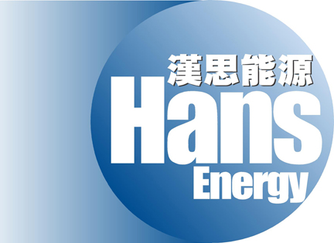

HANS ENERGY COMPANY LIMITED
漢思能源有限公司
(Incorporated in the Cayman Islands with limited liability)
(Stock code: 554)

DATE OF BOARD MEETING

The board of directors (the "Board") of Hans Energy Company Limited (the "Company") announces that a meeting of the Board will be held on Monday, 26th August 2013 at Room 2708-12, 27th Floor, Office Tower, Convention Plaza, 1 Harbour Road, Wanchai, Hong Kong, for the purpose of, among other matters, approving the interim results of the Company and its subsidiaries for the six months ended 30th June 2013 and its publication and considering the payment of an interim dividend, if applicable.

By order of the Board
Fung Chi Kwan, Nicholas
Company Secretary

Hong Kong, 8th August 2013

As at the date of this announcement, the Board comprises four executive directors, namely Mr. David An (Chairman), Mr. Fung Chi Kwan, Nicholas, Ms. Liu Zhijun and Mr. Zhang Lei and three independent non-executive directors, namely Mr. Li Wai Keung, Mr. Chan Chun Wai, Tony and Miss Cheung Siu Yuen, Rose.

