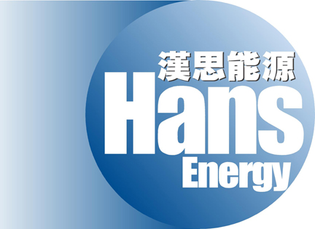

HANS ENERGY COMPANY LIMITED
漢思能源有限公司
(Incorporated in the Cayman Islands with limited liability)
(Stock code: 554)

CLARIFICATION ANNOUNCEMENT
Reference is made to the announcement of Hans Energy Company Limited (the ‘‘Company’’) dated 21 August 2007 regarding the appointment of Mr. Zhang Lei as executive directors of the Compan, the board of directors of the Company (the “Board”) hereby clarifies as follows:

Mr. Zhang Lei, aged 41, has not held any directorship in other listed companies in the past three years before the date of appointment. Save as disclosed, there is no other information that need to be disclosed pursuant to any of the requirements of the Rule 13.51(2)(h) to Rule 13.51(2)(v) of the Rules Governing the Listing of Securities on The Stock Exchange of Hong Kong Limited.

As at the date of this announcement, the Board comprises four executive directors, namely Mr. David An (Chairman), Mr. Fung Chi Kwan, Nicholas, Ms. Liu Zhijun and Mr. Zhang Lei and three independent non-executive directors, namely Mr. Li Wai Keung, Mr. Liu Jian and Mr. Chan Chun Wai, Tony.

By Order of the Board
Chairman
David An

Hong Kong, 22 August 2007

