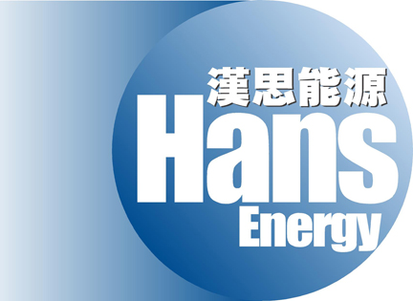

HANS ENERGY COMPANY LIMITED
漢思能源有限公司
(Incorporated in the Cayman Islands with limited liability)
(Stock code: 554)

DATE OF BOARD MEETING
The board of directors (the "Board") of Hans Energy Company Limited (the "Company") announces that a meeting of the Board will be held on Tuesday, 21 August 2007 at Room 2708-12, 27th Floor, Office Tower, Convention Plaza, 1 Harbour Road, Wanchai, Hong Kong, for the purpose of, among other matters, approving the interim results of the Company and its subsidiaries for the six months ended 30 June 2007 and its publication and considering the payment of an interim dividend.

By Order of the Board
Chairman
David An

Hong Kong, 2 August 2007

As at the date of this announcement, the Board comprises three executive directors, namely Mr. David An (Chairman), Mr. Fung Chi Kwan, Nicholas and Ms. Liu Zhijun and three independent non-executive directors, namely Mr. Li Wai Keung, Mr. Liu Jian and Mr. Chan Chun Wai, Tony.

