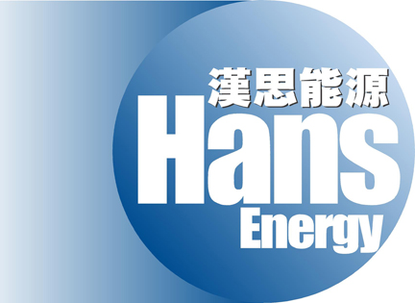

HANS ENERGY COMPANY LIMITED
漢思能源有限公司
(Incorporated in the Cayman Islands with limited liability)
(Stock code: 554)

This announcement is made at the request of The Stock Exchange of Hong Kong Limited (the “Stock Exchange”).

The board of directors (the “Board”) of Hans Energy Company Limited (the “Company”) has noted the recent increases in the trading volume of the shares of the Company and wish to state that we are not aware of any reasons for such increases.

Save and except for the announcement of the Company dated 12 July 2007 in relation to disposal of shares by controlling shareholders, the Board confirm that there are no negotiations or agreements relating to intended acquisitions or realizations which are discloseable under rule 13.23 of the Rules Governing the Listing of Securities on the Stock Exchange (the “Listing Rules”), neither is the Board aware of any matter discloseable under the general obligation imposed by rule 13.09 of the Listing Rules, which is or may be of a price-sensitive nature.

Made by the order of the Board, the directors of which individually and jointly accept responsibility for the accuracy of this announcement.

As at the date of this announcement, the Board comprises Mr. David An, Mr. Fung Chi Kwan, Nicholas and Ms. Liu Zhijun are executive directors, and Mr. Li Wai Keung, Mr. Liu Jian and Mr. Chan Chun Wai, Tony are independent non-executive directors.

By order of the Board
Executive Director
Fung Chi Kwan, Nicholas

Hong Kong, 13 July 2007

* For identification purposes only

